**Performance Evaluation**

The effectiveness of models was tested using two methods: Classification Matrix. The purpose was to determine which model gave the highest percentage of correct predictions for diagnosing patients with a heart disease.

1. **Classification Matrix**: Classification Matrix displays the frequency of correct and incorrect predictions. It compares the actual values in the test dataset with the predicted values in the trained model. In this example, the test dataset contained 208 patients with heart disease and 246 patients without heart disease. Figure 4 shows the results of the Classification Matrix for all the three models. The rows represent predicted values while the columns represent actual values (1 for patients with heart disease, „0‟ for patients with no heart disease). The left-most columns show values predicted by the models. The diagonal values show correct predictions.

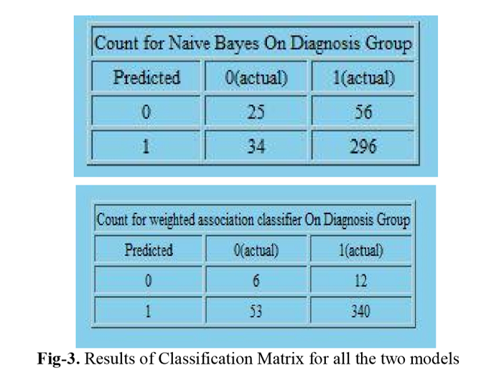

1. **Lift Charts:**

The steps for producing Lift Chart are similar to the above except that the state of the predictable column is left blank. It does not include a line for the random-guess model. It tells how well each model fared at predicting the correct number of the predictable attribute. In the figure the X-axis shows the percentage of test dataset used to compare the predictions while the Y-axis shows the percentage of predictions that are correct. The red, green and blue lines show the ideal, Naïve Bayes and WAC models respectively. The chart shows the performance of the models across all possible states. The model ideal line (red) is at 45-degree angle, showing that if 50% of the test dataset is processed, 50% of test dataset is predicted correctly. The chart shows that WAC gives (84%) followed by Naïve bayes (78%).

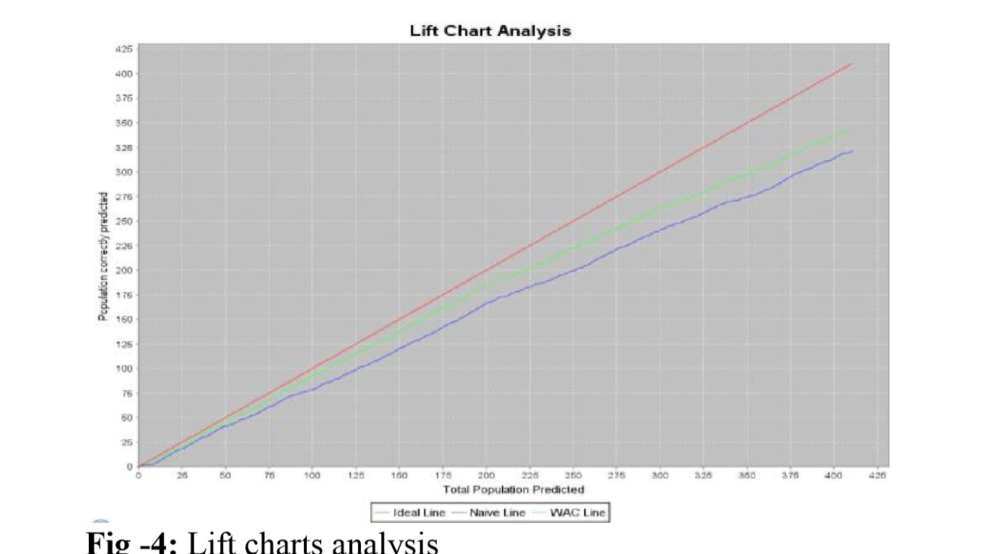

**3. Bar Charts:**

Bar charts as shown in the figure5 actually how many records are taken for testing and out of those how many are with diagnosis “yes ” and how many are with diagnosis “no” and after testing the result analysis in the same manner as shown in below figure5 . From the bar charts below we can say that out of 411 testing records for naive bayes 321 predicted correctly and 90 records predicted wrongly and for WAC 346 predicted correctly and 65 predicted wrongly.

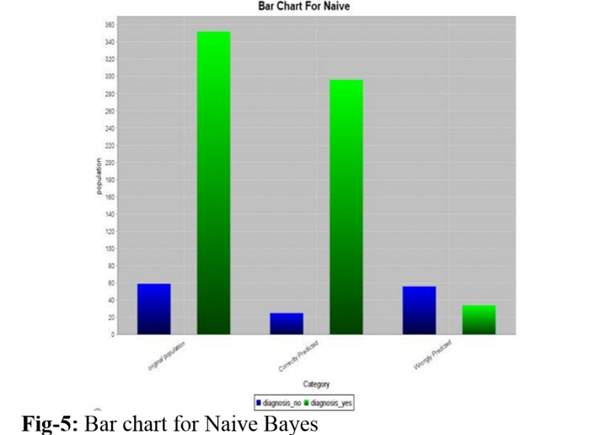

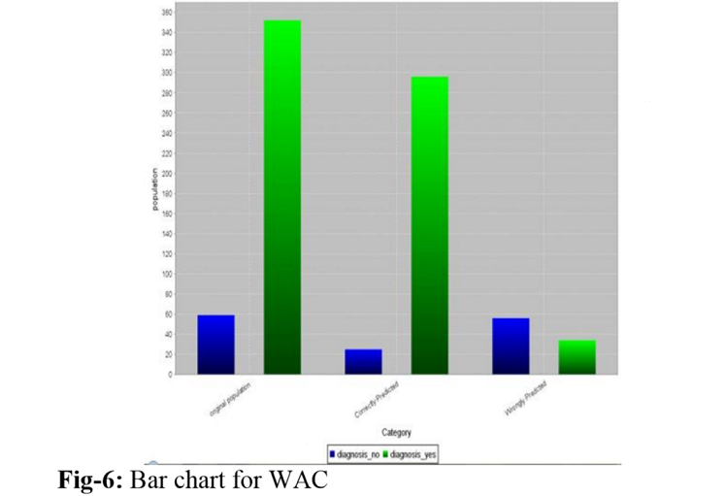

**4. Pie charts:**

The pie chart is perhaps the most widely used statistical chart in the business world and the mass media. Pie charts presented here can explain clearly what the performance level of each technique is.fig 7 shows pie charts for both Naïve Bayes and WAC techniques.

